**SUMMARY OF RESULTS FOR RETAIL CLOTHING COMPANY**

1. **What is the correlation (R2 value) between sales and income?**

The correlation between Sales and Income is 0.78. The following chart presents the scatterplot for the linear regression relationship is linear when the points on a scatterplot follow a somewhat straight line pattern.

Between the variables and the corresponding card with R2 value calculated.

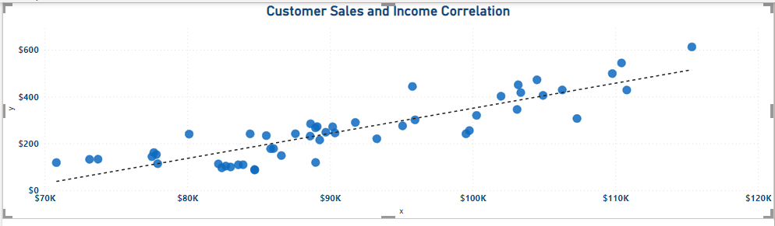

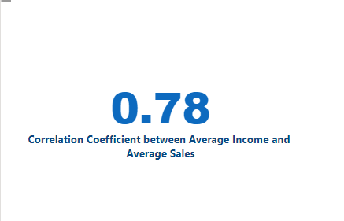

1. What is the correlation (R2 value) between customer ratings and product return rate?

The correlation between Customer Ratings and product return rate is -0.83

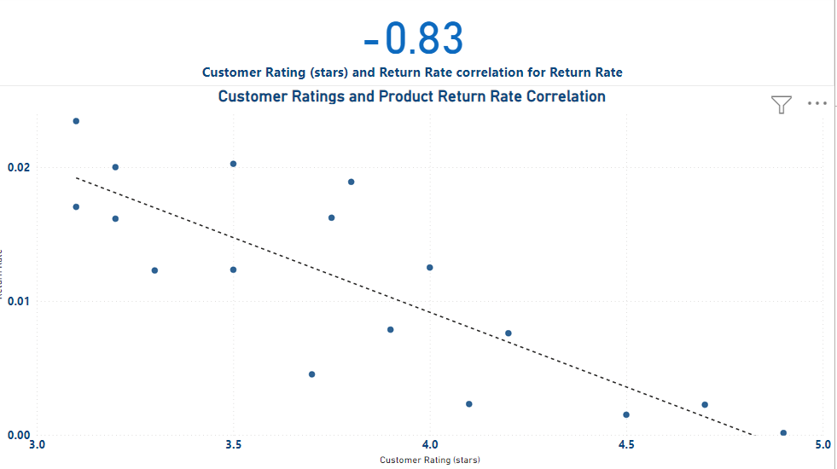

1. What are the linear regression formulas to predict customer sales and customer incomes?

For predict customer sales we use y = 0.0107x - 722.14

For predict customer incomes we use x = (-722.14 – y) / -0.0107

1. Which customer do you predict has the highest income?

The top customer with the highest income is Jon Little from Illinois and born June 3 of 1984. He purchases for $5250 in the last 6 months, his predicted income is $558143.

1. Which product will be advertised the most?

The most advertised product is sweater with a $100 price.

